**DAY 1**

**Program 1:**

Write a program that reads a letter of the alphabet from the user. If the user enters a, e, i, o or u then your program should display a message indicating that the entered letter is a vowel. If the user enters y then your program should display a message indicating that sometimes y is a vowel, and sometimes y is a consonant. Otherwise your program should display a message indicating that the letter is a consonant.

X=input("Input an alphabet ")

if X=="a" or X=="e" or X=="i" or X=="o" or X=="u" :

print("Letter is a vowel")

elif X=="y" :

print("Letter is sometimes a vowel sometimes a consonant")

else :

print("Letter is a consonant")

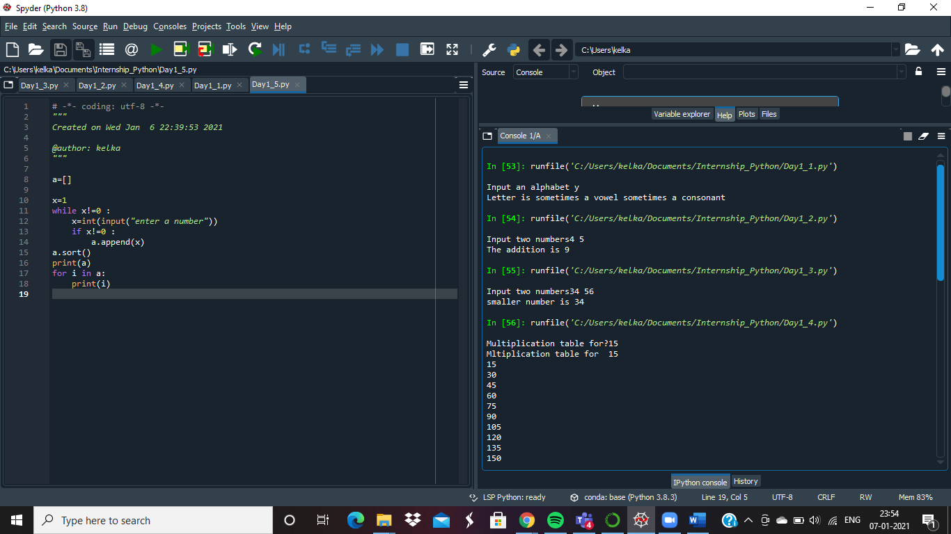

**Program 2:**

You will have to take two numbers (integers) as input and print the addition.  
**Input Format:**  
The first line of the input contains two numbers separated by a space.  
**Output Format:**Print the addition in single line

x,y= input("Input two numbers").split()

print("The addition is " + str(int(x)+int(y)))



**Program 3:**

Given two numbers (integers) as input, print the smaller number.  
  
**Input Format:**  
The first line of input contains two numbers separated by a space  
  
**Output Format:**  
Print the smaller number

x,y= input("Input two numbers").split()

if x>y:

print("smaller number is ",y)

elif y>x:

print("smaller number is",x)

else :

print("Numbers are equal")



**Program 4:**

Write a program for Multiplication Table

x=int(input("Multiplication table for?"))

print("Mltiplication table for ",x)

for i in range(1,11):

print(x*i)



**Program 5:**

Write a program that reads integers from the user and stores them in a list. Your program should continue reading values until the user enters 0. Then it should display all of the values entered by the user (except for the 0) in order from smallest to largest, with one value appearing on each line. Use either the sort method or the sorted function to sort the list

a=[]

x=1

while x!=0 :

x=int(input("enter a number"))

if x!=0 :

a.append(x)

a.sort()

print(a)

for i in a:

print(i)

